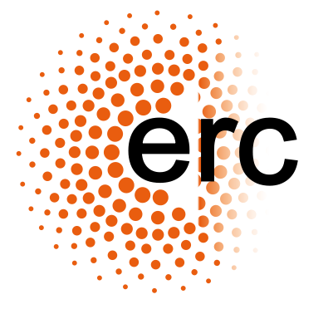

Postdocs positions

There will be funding for a Postdoctoral positions funded by the European Research council ERC Starting grant “Geometric Function theory, inverse problems and fluid dynamics” directed by Daniel Faraco

Length: The grants are planned to start in September 2015, though there is some flexibility in this. . In principle will be one year but the possibility of renovating one year is contemplated,

Salary: The salary will be 50.000 euros a year, according with the usual spanish grants for post doctoral studies.

Candidates and Selection: The candidates should have a PHD on mathematics or physics and backgrounds in analysis, partial differential equations or differential geometry. Relations with the aims of the Project will be appreciated.
A CV should be sent as well as a research plan and a letter of recomendation. After preselection interviews might be conducted.

Deadline: 1st of May.

Daniel Faraco Hurtado

Main Investigator of the ERC Project GFTIPFD

